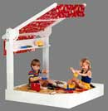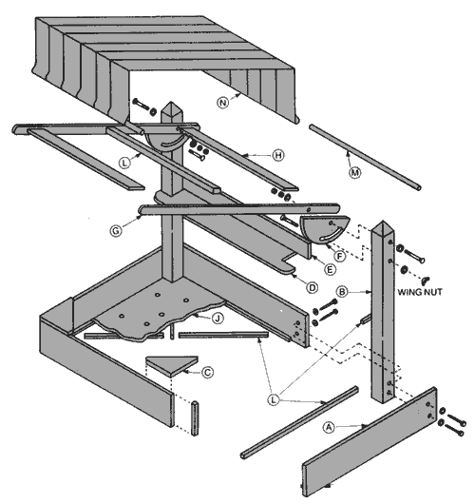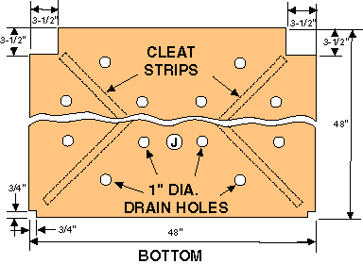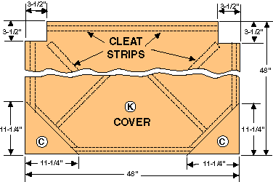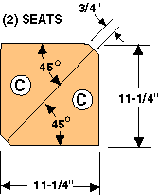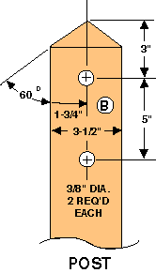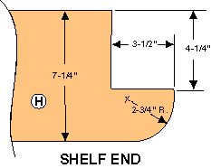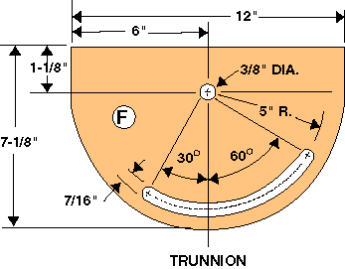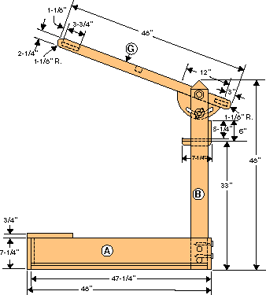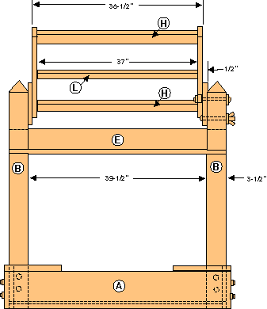

The Sunshade Sandbox
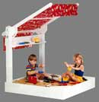
LIST OF MATERIALS
(finished dimensions in inches)
A | Sides (4) | 3/4 x 7-1/4 x 47-1/4
B | Posts (2) | 3-1/2 x 3-1/2 x 48
C | Seats (cut two diagonally from) | 3/4 x 11-1/4 x 11-1/4
D | Shelf (1) | 3/4 x 7-1/4 x 46-1/2
E | Shelf Back (1) | 3/4 x 5-1/4 x 46-1/2
F | Pivot supports (2) | 1/2 x 7-1/8 x 12
G | Canopy sides(2) | 3/4 x 2-1/4 x 48
H | Canopy ends (2) | 3/4 x 3-3/4 x 37
J | Bottom (1) (plywood) | 1/2 x 46-1/2 x 46-1/2
K | Cover (1) (plywood) | 1/4 x 48 x 48
L | Cleat strips (21) | 3/4 x 3/4 x various
M | Dowel rods (2) | 3/4 dia. x 36
N | Sun shade (canvas) | 36 x 60
HARDWARE
(2) | 3/8 "- 16 x 5" long carriage bolts
(2) | 3/8 "- 16 x 6" long roundhead stove bolts
(6) | 3/8" I.D. fender washers
(2) | 1/2" I.D. fender washers
(2) | 3/8" I.D. flat washers
(4) | 3/8" - 16 hex nuts
(2) | 3/8" - 16 wing nuts
(8) | 5/16" I.D. flat washers
(8) | 5/16" x 3" lag screws
(32) | #6 x 1" drywall screws
(5) | #6 x 1-1/4" drywall screws
(4) | #6 x 1-1/2" drywall screws
 | 1/2# 4-penny finishing nails
View Plans &
Assembly Drawings
Assembly
Bottom Layout
Cover Layout

