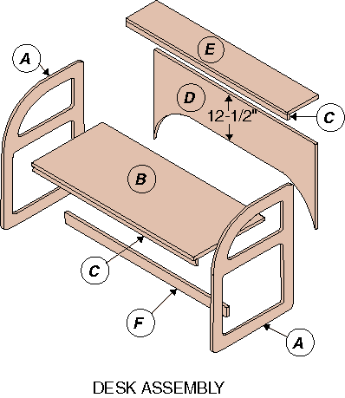
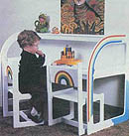
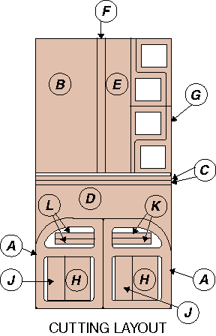
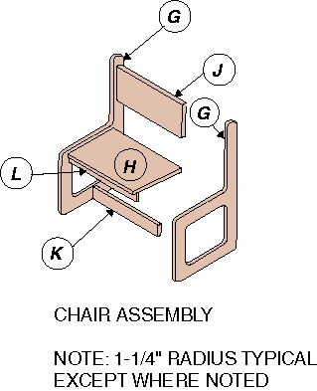
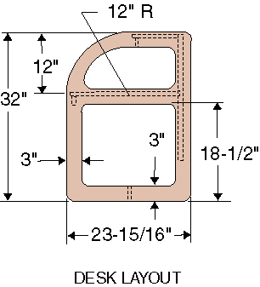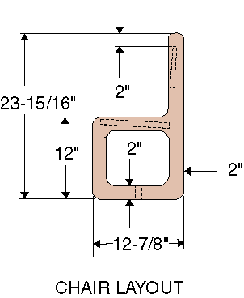
Desk Components
A | Sides(2) | 23-15/16 x 32
B | (Top 1) | 21 x 48
C | Supports (2) | 1-1/2 x 48
D | Back (1) | Irreg. shape x 48
E | Shelf (1) | 9 x 48
F | Spreader (1) | 2-1/2 x 48
Chair Components
G | Sides (4) | 12-7/8 x 23-15/16
H | Seats (2) | 10 x 15-1/4
J | Backs (2) | 6 x 15-1/4
K | Spreaders (2) | 2 x 15-1/4
L | Supports (2) | 2 x 15-1/4

